Couples Planning: Training Protocol

January 19, 2022

Table of Contents
1. Introduction 3
1.1 Project Background 3
1.2 Study Objectives 3
1.4 Study Justification 3
1.5 Planning Certificates 4
2. Planning Protocols 4
2.1 Overview 4
2.2 Important Points to note for GD FOs 4
3. Role of GiveDirectly 5
4. Field Protocol 5
4.1. Registration Script 5
4.2 Planning Certificate Introduction 8
4.3 Planning Protocols 8
Key points to guide planning 8
4.4 Registration Script Continued 9
4.5 Back check script 10
5. Field Scenarios and How to solve them 11
6. FAQ 12

Introduction
This training manual will serve to inform the GiveDirectly Field Officers on the objectives and field protocols for the “Joint Financial Planning” project . This will guide them to execute the suggested protocol modifications to the GiveDirectly Standard Protocol.

1.1 Project Background
Liberia is one of the poorest countries in Africa. The Government of Liberia, with support from the World Bank, United States Agency for International Development (USAID), and Foreign, Commonwealth and Development Office (FCDO), is implementing the Liberia Social Safety Net (LSSN) Project which includes the Social Cash Transfer (SCT) Program. The SCT program provides regular cash transfers to extremely poor and food insecure households in Liberia. An upcoming phase of the SCT program will expand coverage to approximately 6,500 households across Maryland and Bomi counties.

In partnership with the Ministry of Gender, Children, and Social Protection (MGCSP), the World Bank is leading an impact evaluation (IE) embedded within the SCT scale-up in Bomi and Maryland that aims to understand program impacts on beneficiaries and communities. In addition to measuring the effects of the cash transfer program, about 70 of the communities enrolled in the expansion phase will have a joint financial planning exercise offered to cohabitating partners or spouses. The IE will also measure the effects of this program as an accompaniment to the transfers.

1.2 Study Objectives
The following are the study objectives:
- Understand the impact of cash transfers on households’ economic wellbeing and household conflict.
- Understand whether helping a couple make plans for how to spend transfers reduces household conflict.
- Understand whether helping a couple make plans for how to spend transfers helps women give meaningful input as to how money is spent and encourages productive investment.

We address the first objective by comparing outcomes of couples who receive transfers alone to those in the control group. To address the second two objectives, we will compare outcomes for couples who receive transfers alone to couples who receive transfers plus the “couples planning” exercise. During this exercise, the couples will sit down together and decide on a set of shared goals for what to do with their transfer. These goals will be written on a planning certificate as well as a planning poster. A GiveDirectly field officer will facilitate the planning session.

1.3 Study Justification
Every couple must find a way to decide how to manage their household finances, but not all couples make decisions in the same way. Sometimes, couples will make future-oriented plans, while other couples may focus on day-to-day needs. Either way, the male and female partner must decide what items to spend their money on. Different couples plan in different ways: some like to work together and share their money, while others plan independently and use their own money. In other cases, the husband may take the lead as head of households and set spending priorities without consideration of the wife/female partner. In Liberia, data show that the woman often has less say in household spending decisions than the man. One of the goals of our project is to help couples work more collaboratively, by encouraging joint planning.

Better collaboration may increase the woman’s say in how the transfer is spent. Better collaboration may also reduce conflict. As we all know, two members of a couple do not always have the same priorities regarding how to spend and invest money. When spouses/partners disagree, this can cause conflict and stress. The idea behind the joint planning intervention is to give the couple time to reach a shared plan over how to spend transfer income before the money arrives and with the help of a facilitator (the GiveDirectly field officer). We also offer a planning certificate and poster to help the couple remember their plans, which may reduce future disagreement. Our hypothesis is that early, facilitated planning will reduce the likelihood of future conflict and stress. Early planning may also help the couple invest the money more productively.

1.4 Planning Materials
Evidence shows that simple behavioral interventions, like encouraging individuals to make non-binding commitments to use money a certain way, can change how people spend and save. Moreover, focus group discussions with former LSSNP SCT COVID beneficiaries and non-beneficiaries in Liberia indicate that couples believe that financial planning is important, and that it is important to have both spouses engaged in the planning process.

The joint planning intervention, which is described in detail in the next section, therefore involves two parts: first, the GiveDirectly field officer will introduce the transfer program and help the couple arrive at a plan for how to spend the transfer income. Then, this plan will be written on the planning certificate and the planning poster to serve as a reminder. The planning certificate is more detailed than the poster, and couples may wish to maintain the certificate in private while the poster can be hung up in their home; however, it is entirely up to them how and where to store their documents.

Planning Protocols

2.1 Overview
As part of the “couples planning” project, the GiveDirectly field officers will help recipients set goals for how to spend their transfers. Before starting the planning session, please be sure the couple has a clear understanding of the expected amount, number, and timing of the transfers. Once the planning session starts, the couple must first sit with the GiveDirectly field officer and agree on a shared set of goals that they would like to finance with transfer income. As facilitator, the GiveDirectly field officer should:
- Encourage both spouses to participate in the discussion
- Make sure the number and cost of the goals is in line with the value of the transfers. If the couple wants to list a goal that costs more than the transfer income, the facilitator should ensure that they are aware of this, and encourage them to have a plan for the source of the remaining funds. It is up to the couple whether or not they wish to note on the certificate other funds planned.
- The field officer will write these goals down on the “planning certificate”, which recipients will sign as a signal of their (non-binding) commitment to follow through with their goals. The field officer will also fill the planning poster. NOTE: when filling the planning materials please write neatly using block letters to ensure everything is easily read. You should also use the included pack of stickers to affix a visual reminder of each goal on the planning materials.

Beneficiaries will also be given a set of star stickers, which they can affix to the relevant line on the certificate and poster once a goal has been achieved. The planning materials will serve as a reminder of the goals the couple has committed to, while the star is designed to fill them with a sense of pride upon achievement of their goals.

2.2 How to Fill the Planning Materials

Sample of Planning Certification with embedded guidance how to complete it with couple:

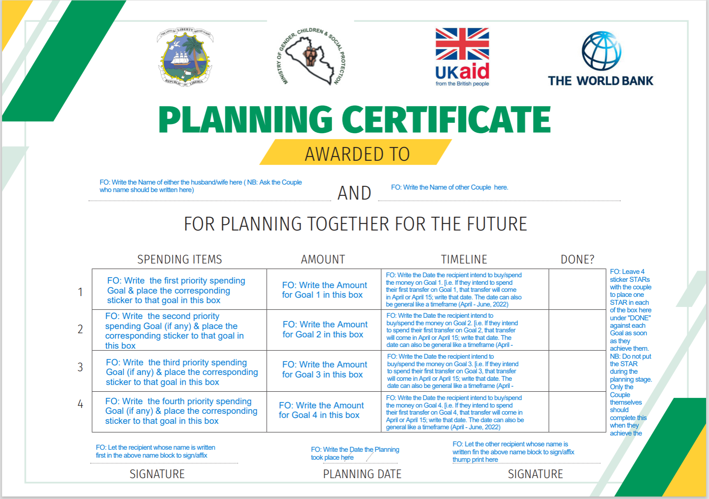

Sample of Planning Poster with embedded guidance how to complete it with couple:

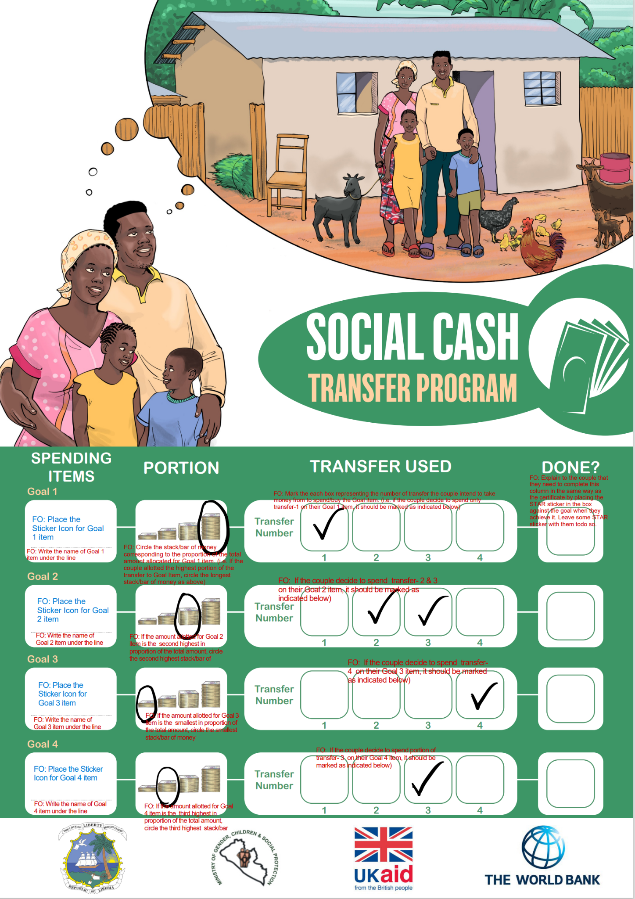

2.3 Important Points to note for GD FOs

- Meet with the couple together: In communities where the financial planning intervention is offered, everyone will be advised that both members of the couple should make themselves available for the registration visit (during which financial planning will be conducted). If you arrive for the registration visit and one or both members of the couple are not present, you should attempt to reschedule at a time when both can be present. You are expected to make two attempts to reschedule with the couple.

If ultimately you cannot meet with both partners present, you can offer the individual who is present to engage in financial planning alone in the visit in which you conduct registration. However extra effort must be made to carry out the financial planning intervention with couples that were covered by the baseline survey. Similarly, in households that do not have a cohabiting couple living in the household, you may offer financial planning to any adult present on the registration visit who would like to participate.

DO: Offer planning to all households in communities selected for this intervention.

DON’T: Insist that households participate in planning if they do not wish to.

- Get informed consent: In all cases, potential beneficiaries must be fully informed of the proposed planning process before deciding whether or not they want to participate. Only individuals that freely give informed consent should participate in the planning sessions. The field officer should explain the benefits of participating in the planning session, but it is also important to be clear that participating in the planning session is in no way tied to receipt of the transfers.

DO: Remind respondents that their eligibility for transfers is entirely separate from participation in this voluntary process. Ask respondents after they have provided consent if they understand that this is fully voluntary.

- Explain that goals are non-binding: We are asking the couple to set goals as a way to plan for a better future. But sometimes the couples’ needs change over time. Therefore it is not a problem if people don’t meet all their goals, and whether or not a couple meets their goals will have no impact on their standing with GiveDirectly, the Government of Liberia, the World Bank, or any other organization. You should remind the couple that if they need to change their goals, it is good to decide on this together to ensure there is agreement.

DO: Remind couples that households who receive grants can spend them in any way they want in order to improve their lives. Their use of the transfer is up to them, and GiveDirectly staff will not be checking on them to see if they have followed their plans.

DON’T: Encourage or press couples to choose particular financial goals. The goals are entirely up to them.

- Emphasize confidentiality: Remind couples that you are only there to assist them in planning and filling out materials. Any information that they share is fully confidential. You will not share any information about their planning goals with anyone at GiveDirectly or in their community. GiveDirectly staff work with Liberian households to register them for cash transfers all the time, and maintaining privacy of households’ personal information is one of their highest goals. This information is in the consent statement, but you can also remind households at any time.

DO: Ask follow-up questions to ensure respondents understand that you will not be reporting the results of the planning process to anyone. Any summaries made about the project will not include any personal information that could identify them.

DON’T: Insist that respondents share any personal information they do not wish to. They can choose to formulate a more general plan with you if they don’t wish to share details; they can have a private conversation on the side, and then just work with you to fill out the materials; or they can opt to conduct the planning process on their own if they wish to. The field officer should encourage couples to participate, but if they do not wish to, they can be provided with the materials to proceed on their own, and the FO can move on to the next household.

- Use visual tools: Since many GiveDirectly beneficiaries are illiterate, GiveDirectly field officers will be given a set of stickers, which depict common goals (e.g. education-related expenses, food, rent and shelter materials like zinc, health care costs, business investments, land, clothes or shoes, etc). Use these stickers on both the poster and certificate to ensure even illiterate beneficiaries can understand the planning materials. The FO can also add text elaborating on the specific goal underneath the sticker on the poster and next to the sticker on the certificate for their records.

DO: Explain clearly to illiterate beneficiaries what you are filling out, and show the visual tools at the same time. Ensure that the poster and certificate are filled out in the way most helpful for the specific participants.

- Take account of timing: since SCT program transfers will arrive in 4 batches of XXXX dollars each, be sure to help the beneficiary think about when they will purchase their goals. Ensure they have a realistic date in mind before filling this information on the certificate.

- Make sure plans are clear: Participants cannot benefit from their plans if they don’t understand them. Once you have filled the certificate and poster, ask the couple to explain their plan to you, referring to the planning materials. If they are unclear or have questions, be sure to answer them.

DO: Offer multiple opportunities for participants to ask questions about the process.

DON’T: Insist that participants fill out all sections of the materials if they don’t wish to, or insist that they sign if they don’t wish to. The materials are for their benefit, and different couples may choose to use them in different ways.

- Encourage collaboration: Our objective is to have both the male and female partner give inputs into planning. Encourage both partners to offer their ideas. Sometimes one partner may be more quiet and may require prompting to contribute. Give positive feedback when both participate.

DO: Offer opportunities for both partners to speak by calling on them by name.

DON’T: Have a long conversation with only one partner. Continue to offer opportunities for the second person to participate.

- The goal is to encourage peaceful planning. Let the area be a safe space for both the man and woman to respectfully air their views on how the money should be spent. Remember that the planning exercise is voluntary. If one or both members of the couple becomes upset, think about what would defuse the situation. In some cases it may be best to end the planning exercise and courteously wrap up the session. GiveDirectly field officers are not expected to insert themselves into a couple’s disagreement.

DO: If an argument becomes heated, remember you can thank the couple for their time, and note that you will leave the materials for them to complete at a later time if they wish.

DO: If you have any concerns about potential violence as a result of an argument, communicate this to your supervisor.

- Encourage the woman to be confident about her plans. Assure the woman and make her feel comfortable that her ideas matter and are worth inclusion
- Encourage the man that this exercise is not to undermine his role as a man but rather to include his wife in the planning process so as to make better-informed decisions.

Role of GiveDirectly
GiveDirectly staff will administer the planning protocol and in the process, help recipients set goals for how to spend their transfers.

Directions on Goal setting:
- These goals will be written down on the planning certificate and the planning poster.
- Recipients can sign the planning certificate as a signal for their non-binding commitment to follow through with their goals. Illiterate participants can make their mark with a thumb and ink pad. Signing the certificate is not compulsory if respondents do not wish to sign.
- Recipients will be provided with star stickers, which they can affix to the relevant line of the contract upon achievement of the set goal.

The planning sessions will take place during the registration process. During the planning session, the field officer will complete a short form to confirm details of the exercise. This form will also include the introductory script to the planning certificate and the consent script where the participant can opt out of the exercise; a short audio clip and the GPS location will be recorded in the background of the form to be used as a form of quality assurance.

Field Protocol

4.1. Registration Script
The overall objective of this script is to ensure that (1) you are enrolling only the right recipients, and that (2) they are ready to receive their money. Note: ** denotes that you need to ask the recipient to show you something and instruct them on how to do it if they do not already know. It may require some time to teach them these things.

<<Insert GD registration script for SCT program in Liberia, which includes the standard GD introduction, explanation of eligibility and cash transfer program, and collection of data for enrollment and registration.>>

4.2 Planning Certificate Introduction
You will facilitate the planning process using the following script to guide you through the joint financial planning exercise with all individuals who agree to participate in the appropriate communities. This script has been preloaded into the SCT Intervention Form on SurveyCTO. For each session that you facilitate, you will open this form, select the correct location, and enter the LHSR ID and Baseline ID (where applicable) into the form. Please note that it is important to look carefully for the Baseline ID (format XXXXXXXXBLXX) above the doorway to where the household is living. In cases where there are multiple households living in a structure, this may be inside the building above the door to their room, and will not necessarily be on the outside of the house.

Field officer read: In addition to the cash transfer, the LSSNP SCT Program offers a service to aid you and your spouse in setting some goals for how to spend your transfers. We will do this by first deciding on goals together. Then I will write down the details of the goals on a planning certificate <<show certificate>>. We can also put the goals on this poster <<show poster>>, which you can keep in your home. Both you and your partner would be involved in the planning process – I will explain how in a minute.

It is up to you to decide whether or not you want to participate in the planning session. The main benefit is that you will work together to make a plan for how to spend your transfers. We do not want to bring palava in your home, sometimes we have seen either the husband or the wife take the money and just use it on something that is not good or agreed on. This can make a problem come in, and we have stopped transfers in the past in that kind of situation until the confusion is fixed. Good planning can keep this from happening.

But remember that LSSNP SCT Program does not want to interfere with you or your spouse’s decision making on how you will spend your money. It is completely up to both of you to spend the money as you want it.

The planning will take about 20 minutes. Your decision about whether or not to plan will not affect your eligibility for transfers or your standing with the program

Is it ok if I go ahead to explain how the planning process works?

[[IF NO]]
Field officer read: Ok that’s fine. <<GiveDirectly registration script continues>>

[[IF YES: explain to the respondents the planning protocol, taking them slowly through the process to ensure they understand each component.]]

Field officer read: Thank you for participating. Before we go far, I want to explain how we will use this certificate to remind you of your plans. This certificate <<**display certificate>> is for you. We will fill it together and I will leave it with you to keep. We will write your goals in the first column of the certificate here <<**point to column>>. I also have these stickers with me so we can add a picture of each goal.

For example if me and my spouse wanted to buy a goat, I would write “goat” here and place this sticker picture as a reminder.

Next to the sticker we put the amount. So in my example if we want to buy a goat for 3500 LD, I would mark that amount here.

Next we will write the date for your goal. For example if me and my spouse want to buy a goat with our second transfer, and that arrives in <<date>>, I would mark <<date>> here. When you do your own planning, you can pick specific dates or more general dates, like “June-July” -- it is up to you.

The last column is labeled “done” -- this is for you to fill once you meet your goal. I will leave these star stickers with you, so when you meet your goal, you add a star. This is to celebrate your achievement and give you pride.

If there is any part of the certificate you don’t want to fill out right now with me, that is fine as well. It is up to you how to fill out the certificate and use it, and you and your spouse can always come back to the certificate at a later time.

Do you have any questions about how we will fill the certificate?

Ok, now it’s time to make your plans. Our goal is for you to plan together and feel good. As the husband, you should feel proud to be taking care of your family by making a good plan. As a wife, you should feel confident in sharing your ideas and participating. As we say, “TWO HEADS ARE BETTER THAN ONE”.

Remember, the transfers will come like this <<summarize number, amount and rough timing to the couple as indicated below>>.

Transfer Timeline Table
 | Wave-1 Recipients  (Recipients as per Enrollment Workplan) | Wave-2 Recipients  (Recipients as per Enrollment Workplan) | Wave-3 Recipients  (Recipients as per Enrollment Workplan)
Transfer 1 | April 15, 2022 | May 15, 2022 | June 15, 2022
Transfer 2 | July 15, 2022 | August 15, 2022 | September 15, 2022
Transfer 3 | October 15, 2022 | November 15, 2022 | December 15, 2022
Transfer 4 | January 15, 2023 | February 15, 2023 | March 15, 2023

Transfer size based upon the household size
Size of Household | Monthly transfer size (USD) | Quarterly transfer size (USD)
1 | 10 | 30
2 | 16 | 48
3 | 22 | 66
4 | 28 | 84
5+ | 34 | 102

First, let’s write down the things you would like to use the money for. People in the past have spent on many different things. <<**Field officer: Go through the options corresponding to the list of stickers provided, and reassure them that anything else they might want to do is also allowed>>. This is not a suggestion that you should use the money for the same items, just some ideas to get started.

<<**Field officer: ask each spouse to list their priorities, and you can write them down on your notepad; if helpful, make two columns, one for each spouse’s priorities. If one spouse is quiet, gently encourage him or her to contribute>>

OK, here are your ideas: <<**read list on notepad. If one spouse has not contributed, ask if they have anything to add>>.

Now I’d like you to discuss together what items are most important. I can help you keep track of the money amounts to make sure your plan can be met.

<<Field officer: let the couple decide what items are most important. Ask them how much these items will cost and how much transfer money they need to use to reach the goal. Keep a tally of expenses to ensure the plan is realistic>>

OK, so these are your most important goals. <<**Read list>> Now I will write these down on the certificate. Let’s start with the goal that is most important to you. Or, if you are unsure as to the relative importance, you can choose your own order in which to present the goals.

<<**Field officer: put the goals on the certificate in order from most to least important or in the order you want to achieve your goals, using stickers. Write the amounts down as well>>

Now let’s decide on timing. Remember, the transfers will come like this <<**Field officer: repeat transfer schedule and amounts>>. When do you think you can buy each of these items? Remember, if you are not certain, that is OK too; you can note when you think you might buy the items, or you can always leave a section blank and fill it in later or not at all. <<**Field officer: help couple fill dates for each item on the certificate>>

Congratulations, you have made your plan! Let’s go over the certificate together to make sure everything is right. <<**Field officer: review the certificate with the couple to make sure they understand and agree. Ask them to explain it back to you to be sure they understand>>

Now it’s time for you to sign the certificate to show your commitment. If you cannot write, you can make your mark with this pad here. If you don’t want to sign, that’s OK too.

<<**Field officer: write the couple’s names on the top of the certificate and add the planning date. Let them sign at the bottom>>

You can do whatever you want with this certificate. We know some people like to keep it private, so we also have this poster you can put on your wall if you want. <<**Field officer: show poster>>
We will put the same plan on this poster. You can decide where to put it after I leave. First, let’s put stickers for your goals on the poster. <<Affix stickers>>
To keep things more private, we won’t put money amounts on the poster. Instead we have these pictures of small, medium, and big stacks of cash to show how big the expense is. Let’s mark this next. <<**Field officer: work with couple to circle cash amounts for each goal>>
Next for timing we have four boxes to represent each of the mobile money transfers your household will receive. We will now mark which transfer you plan to use money from to spend on this goal. If you will use money from different transfers, we will mark all transfers that apply.. <<**Field officer: work with couple to mark timing for each goal>>
And just like the certificate, this last part is for you to mark with a star once you meet your goal. Here are the star stickers for you to use on your own. <<**Field officer: give couple poster, certificate, and star stickers>>
We hope the certificate and poster will be a good reminder for you. Let me also make it clear that if you make the plan, you are not forced to go by that plan, you can decide as a couple to do something else with the money if you want and this will have no impact on you receiving money from this program, the Government of Liberia, the World Bank, or any other organization. No one will be checking up on you or requiring that you demonstrate how you spent the money in accordance with your plan. If anyone asks you questions that seem uncomfortable or intrusive, you should report this to through the hotline (4483) right away.
Also, remember that you can always modify your certificate and poster later by writing or drawing on the poster. You can note any new items or any changes to your plans. The poster is intended to be useful to you as you move forward in your financial decision-making.
Thank you very much for planning together. I hope it was helpful. Now that you know how to plan together, you can use this process for other big decisions you need to make in life.
Do you have any questions for me? If you want more advice or to discuss your plan, you can call the hotline number: 4483.

4.3 Summarizing the Intervention
After completing the exercise with the participating couple, you will record pictures of the certificate and poster, then answer a short set of questions about how the session went and what was decided on, including information on:
- Attendance and participation,
- Goal setting and budget allocation, and
- Any disagreements that took place during the planning.

4.4 Registration Script Continued

<<Continue with GD registration script for SCT program in Liberia, which includes the standard GD information-sharing on theft-awareness, audits, follow-up, using the hotline, and withdrawal from program.>>

5. Field Scenarios and How to solve them
The field scenarios are taken from previous field experiences in research projects. They serve as a way to solve projected challenges that might be encountered in the field.

Instructions
For the following field scenarios, print the scenarios single- sided and cut them up. Randomly pass out the scenarios to each trainee. In small groups of 2-3 people, have the trainees discuss their scenarios with each other and come up with ways to go about those scenarios in case they face them in the field. After some time, have the team come back together to discuss as a large group their solutions to the respective scenarios.

Field Scenarios
- The respondents are worried that the planning certificate interferes with their day to day form of planning. What can you do to make them feel more comfortable?
Answer: The certificate is not intended to interfere with day to day planning but rather reinforce and help with the planning process and encourage couples to follow through with their plans. The certificate will help the couple remember what priorities they have.

- You have a female respondent who agrees to participate in the study, but her husband insists on not allowing her to even listen to you. What do you do?
Answer: Talk to the husband and explain to him that the study is not meant to interfere with his role as the head of the house but rather to allow his wife to support him in the decision-making process to allow them to make better decisions. However, if there seems to be a more significant conflict emerging as a result of the study, apologize, note that their decision is respected and record the household as a “refusal.”

- You meet with a scenario whereby the respondents are not willing to share information with you. You ask them questions but they refuse to answer. What do you do?
Answer: Encourage the respondents to be truthful and explain that the study is meant to help them better plan and follow through with their plans. Also emphasize that these goals are theirs; hence if they are not comfortable sharing them, you will leave them to discuss the plans within the couple and write them down once they have agreed on the plans. However, if the couple remains uncomfortable sharing information, then thank them for their time and note them as a refusal. You can leave the planning materials with them to use as they wish.

- What would you do if the respondent became angry that you are asking personal questions?
Answer: Assure them that the study will be completely confidential and that the plans with their spouse will be largely up to them to decide and follow through. Emphasize that LSSNP SCT Program wants the recipients to use their money as they wish and hence the questions are merely to help them think about how they want to spend their money once they receive it.

- After talking with the respondents, they ask you to help his/her daughter get a job where you are working. What do you do?
Answer: Emphasize that the role of GiveDirectly in the community is not to give jobs but rather to distribute cash transfer and empower the community. Remind them that they can contact GiveDirectly through the hotline number provided to everyone in the community, but they cannot contact you directly.

- Respondents are concerned that you are devil worshipers and are threatening to tell the whole community, what do you do?
Answer: GiveDirectly is an independent organization that does not have any religious affiliation. We have authorization to carry out our activities from the local authorities. Our activities are to empower the community economically so that the community may grow and thrive. Remind the respondent that GiveDirectly conducted a community meeting recently at which the whole community, including leaders, was fully and publicly informed about GiveDirectly’s activities, and the community’s questions are answered. If the respondent still seems uncomfortable or angry, report this to your supervisor.

- Respondents tell you how much they are suffering and are expecting you to act by giving them an extra amount to sort these problems, how do you go about this?
Answer: The company policies are specified that every individual is entitled to the specified amount. We want to promote equality so that no one member of the community will feel that they have been favored over another. Therefore all those who are under GiveDirectly are treated the same and given the same amount of money. Remind the respondent again that all community members were informed of these policies in a public meeting.

- You are in the middle of the planning protocol and your couple starts to argue about how to spend the money. What do you do?
Answer: Do not insert yourself into their argument and do not put yourself at risk. Tell the couple that you understand that planning can be stressful and they do not need to complete the plan if it is a source of stress. Make sure they understand they will still receive their transfers. Then work to end the conversation and leave the house. Report the case to your supervisor and mark the reason for incomplete planning in the intervention form.

9. You visit a home and one of the couples left the home (felt ill or went hunting for a week) but consented for the person at home to do the planning.
Answer: What to do here depends on the number of attempts you have made and whether the couple is part of the impact evaluation. Based upon the number of survey attempts for the particular household in the revisit roster, and whether the household is baselined or not, you can complete the financial tools or not. You should review the number of attempts in the revisit roster to know the number of attempts. You can know if a couple is part of the impact evaluation by looking for the baseline ID written above the door of the part of the structure where the household lives. Remember it follows format XXXXXXXBLXX. DO NOT ASK ANY COUPLES IF THEY HAVE PARTICIPATED IN A RECENT SURVEY OR IF THEY ARE PART OF THE IMPACT EVALUATION.
For couples that are part of the impact evaluation, you need to make three (3) attempts to do in person joint planning. So if you are on your first or second attempt, ask the person at home if there would be a good time to come back to do the joint planning and set an appointment. If it is your third attempt, you can attempt to contact the absent spouse via phone and jointly complete the planning tool; if unsuccessful, you can complete the planning tools with the available person (i.e. husband or wife) and indicate that in your notes within the intervention form.
For couples that are not part of the impact evaluation, you need to make two (2) attempts to do in person joint planning. So if you are on your first attempt, make an appointment for a re-visit as above. If it is your second attempt, please continue and contact the spous by phone, or complete the financial planning tools with the available person (either husband or wife).

10. There is a couple who are very old and relied on their daughter/son for financial planning, they make no decision because they are very old. What do we do here?
Answer: In this case, you should do the planning with the daughter/son included. Please follow the above protocols regarding attempts for joint planning. If it is not possible to include the daughter/son, then it is up to the respondent to decide if they want to fill out the planning materials on their own.

11. The head getting the transfer is not capable of understanding the planning, e.g. because he/she is deaf or mentally unwell.
Answer: Such an individual should not meet the program’s definition of head of household. Do not do the planning exercise and report this case to your supervisor.

12. One member of the couple is temporarily not capable of planning, for example because he/she is very drunk.
Answer: Do not do the planning at this time. If this is not your final attempt, make an appointment to do the planning at a later time. If this is your final attempt, mark the couple as “planning not completed” and enter the reason in the form.

13. The head of household is single, or his/her partner does not reside in the community
Answer: Do the planning with the head alone. If there is someone else in the household the head usually plans with, you can invite them to join the planning session. Whenever doing the intervention with a single household head (or divorced/widowed/etc.) the emphasis can be placed on the importance of planning rather than on the importance of joint planning. The other protocols above can be followed, but instead of trying to facilitate joint decision-making the FO just focuses on clearly capturing the goals of the individual.

FAQ
- Why are you encouraging joint planning between men and women?
Answer: This is because women are sometimes overlooked and not provided an equal say in some households with regards to financial planning. The study merely wants both spouses to be included in the financial decision making process. We believe that this can make the outcomes of the planning process better.
- How will this reduce conflict in the household?
Answer: We are encouraging the couple to be clear about their goals, to sit down and take time to discuss how the money is spent, and to come to an agreement about how to spend the transfer. Ideally this will encourage transparency and create a platform to discuss any disagreements in a civilized manner before any conflict arises.

- Why are we using the certificates to write down our plans?
Answer: Research has proven that use of soft commitment devices can encourage following through with plans. Hence we are looking to encourage couples to spend their money wisely on what they themselves categorize as priorities in the household. This will deter unnecessary and unplanned spending.

